AMENDED AND RESTATED DECLARATION OF COVENANTS
CONCERNING PAYMENT IN LIEU OF TAXES
This Amended and Restated Declaration of Covenants (the “Declaration”) is made as of December __, 2021, by VINEYARD II LLC, a Delaware limited liability company f/k/a IP VINEYARD LLC (the “IP Declarant”), VINEYARD LLC, a Colorado limited liability company (the “Vineyard Declarant”), and VINEYARD METROPOLITAN DISTRICT, a quasi-municipal corporation organized and existing in accordance with Article 1 of Title 32, C.R.S. (the “District”), for the benefit of the COLORADO SPRINGS URBAN RENEWAL AUTHORITY, a body corporate and politic of the State of Colorado (the “Authority”).
Recitals
A. The following recitals and all exhibits attached to this Declaration are incorporated in and made a part hereof. Unless otherwise stated, all capitalized terms shall have the meaning set forth in this Declaration.
B. The IP Declarant owns the real property described as the IP Parcel in Exhibit A-1 and the Vineyard Declarant owns the real property described as the Vineyard Parcel described in Exhibit A-2. The IP Parcel and the Vineyard Parcel constitute substantially all the real property within the boundaries of the Vineyard Plan, which is being carried out and administered by the Authority, other than the property conveyed to SAP America Inc. in 2016.
C. The Vineyard Declarant and the Authority are the original parties to the Amended RRA. The Vineyard Declarant subsequently assigned its interest in the Amended RRA to the IP Declarant. The Amended RRA provides, inter alia, that the IP Declarant shall be reimbursed for those Eligible Costs paid, documented, and certified by the IP Declarant and approved by the Authority. The Amended RRA pledges and creates an exclusive first lien on all TIF Revenue produced in the Vineyard Plan Area in favor of the IP Declarant.
D. To accelerate reimbursement of Eligible Costs to the IP Declarant, the Authority has entered into the Loan Agreement with Vectra, and to facilitate such financing, IP Declarant assigned its priority right to receive TIF Revenue to Vectra.
E. To assure and protect Vectra, its successors and assigns, as well as the Authority, from the possibility that the IP Parcel and the Vineyard Parcel or any portion thereof may during the Term be exempt from property taxation causing a deficiency in the TIF revenue payable to Vectra under the Loan Agreement the IP Declarant and the Vineyard Declarant, on behalf of themselves and their successors in interest, declare and covenant to pay certain amounts to offset any such deficiency as set forth herein.
F. The IP Declarant, the Vineyard Declarant and the District are parties to that certain Declaration of Covenants Concerning Payment in Lieu of Taxes dated as of September 23, 2021 and recorded in the Records (as defined below) on September 23, 2021 at Reception No. 221178629 (the “Original Declaration”), and this Declaration is intended to amend and restate the provisions thereof.
Agreement
NOW, THEREFORE, in consideration of the Recitals and other good and valuable consideration, the receipt and adequacy of which are hereby acknowledged, the IP Declarant, the Vineyard Declarant and the District hereby declare and agree as follows:

Definitions. In this Declaration, capitalized terms shall have the following meanings:
“Act” means the Colorado Urban Renewal Law, Part 1 of Article 25 of Title 31 of the Colorado Revised Statutes.
“Amended RRA” means the Vineyard Redevelopment and Reimbursement Agreement dated as of September 5, 2012, as amended by the First Amendment to Vineyard Redevelopment and Reimbursement Agreement dated as of June 23, 2020 and by the Second Amendment to Vineyard Redevelopment and Reimbursement Agreement dated as of September 23, 2021.
“Annual Fee” means, with respect to any Exempt Property, an annual payment in lieu of taxes in the amount equal to the Mill Levy for the applicable calendar year that would be imposed on and apply to the Property, or applicable portion thereof, if it were not Exempt Property, multiplied by the County Assessor’s most recent certified final appraised valuation of such Exempt Property, and multiplied by 29% (or such other percentage as prescribed for taxable commercial property pursuant to Section 39-1-104(1), C.R.S., as amended).
“Authority” means the party described in the first paragraph of this Declaration and any lawful successors and assigns.
“Declarant” means, collectively, IP Declarant and Vineyard Declarant.
“District” means the party described in the first paragraph of this Declaration and any lawful successors and assigns.
“Exempt Property” means any portion of the Property that would be subject to imposition and/or payment of the Mill Levy, excluding any portion of the Property dedicated to the City of Colorado Springs, Colorado, or the District for public infrastructure, but is exempt from ad valorem property taxation as disclosed by the County Assessor’s records, and therefore such property is not subject to, or is exempt from, the imposition and/or payment of the Mill Levy.
“Eligible Costs” means those costs paid, documented, and certified by IP Declarant and approved by the Authority in accordance with the Amended RRA.
“Interest” means a fee simple ownership interest, subject to matters recorded in the Records.
“IP Declarant” means the party described in the first paragraph of this Declaration and any lawful successors and assigns.
“IP Parcel” means the real property described in Exhibit A-1, which is owned by the IP Declarant.
“Loan Agreement” means the Loan Agreement between the Authority and Vectra dated as of June 23, 2020, as amended by the First Amendment to Loan Agreement dated as of April 27, 2021, and by the First Amendment to Loan Agreement dated as of September 23, 2021, whereby, subject to coverage requirements, Vectra agrees to advance loan funds not to exceed $15,000,000 to reimburse IP Vineyard for approved Eligible Costs. The Loan Agreement also includes any refinancing or refunding of the Loan Agreement.
“Loan Documents” means the Loan Agreement, the Custodial Agreement executed in connection therewith, and any other documents or instruments executed in connection with the foregoing.
“Mill Levy” means the aggregate ad valorem property tax mill levies imposed by the Taxing Entities from time to time.
“Owner” or “Owners” means, as of the date of this Declaration, (a) individually, IP Declarant or Vineyard Declarant and individually any transferee and successor holding a fee interest in the IP Parcel or the Vineyard Parcel or (b) collectively, both IP Declarant and Vineyard Declarant and collectively such transferees or successors in interest to a fee interest.
“Property” means, collectively, the IP Parcel and the Vineyard Parcel.
“Records” means the real property records of the Clerk and Recorder of El Paso County, Colorado.
“Taxing Entities” are the governing bodies of the various taxing jurisdictions within or overlapping the Property.
“TIF Revenue” means, with respect to the Vineyard Plan, all annual ad valorem property tax revenue received by the Authority from the El Paso County Treasurer in excess of the amount produced by the levy of those taxing bodies that levy property taxes against the base value in accordance with Section 31-25-107(9)(a) of the Act and the regulations of the Property Tax Administrator of the State of Colorado, but not including any offsets collected by the El Paso County Treasurer for return of overpayments or any reserve funds retained by the Authority for such purposes in accordance with Sections 31-25-107(9)(a)(III) and (b) of the Act. The base value and increment value shall be calculated and adjusted from time to time by the El Paso County Assessor in accordance with Section 31-25-107(9) of the Act and the rules and regulations of the Property Tax Administrator of the State of Colorado.
“Vectra” means Zions Bancorporation, N.A. DBA Vectra Bank Colorado and its successors and assigns.
“Vineyard Declarant” means the party described in the first paragraph of this Declaration and any lawful successors and assigns.
“Vineyard Parcel” means the real property described in Exhibit A-2, which is owned by the Vineyard Declarant.
“Vineyard Plan” means the Vineyard Property Urban Renewal Plan approved by the City Council of the City of Colorado Springs on March 22, 2011.
“Vineyard Plan Area” means the area within the boundaries of the Vineyard Plan.

Colorado Common Interest Ownership Act Not Applicable. This Declaration is recorded against and encumbers 20 or fewer “units” and does not reserve any “development rights” as those terms are defined in the Colorado Common Interest Ownership Act, Sections 38-33.3 – 101, et seq., C.R.S., and is therefore exempt from the provisions thereof as of the date of this Declaration.

Term. This Declaration of Covenants and all obligations of any Owner shall expire, terminate and be of no further force or effect upon the earlier to occur of (a) payment in full of all amounts due and payable under the Loan Agreement as defined herein, (b) such time as the second completed building in the Vineyard Plan Area is included in the assessed value of the Property, adding a minimum of $1,372,892.99 of incremental assessed value, as provided in the Amended RRA, or (c) December 31, 2036 (the “Term”); provided, however, the obligations and liabilities of any Owners accruing during the Term, and the Authority’s enforcement rights in connection therewith, will survive the expiration of the Term. In the event of the occurrence of either of the conditions in the foregoing clause (a) or (b), the parties hereto and the Authority shall execute an instrument acknowledging such occurrence and termination and the Authority shall record such instrument in the Records.

Annual Fee.

Declarant acknowledges and agrees, and each Owner acquiring an Interest in any portion of the Property will be deemed to have acknowledged and agreed, that the Authority may and will calculate and collect, and the Owners from time to time of Exempt Property will pay to the Authority, the Annual Fee in arrears as set forth below during the Term.

On or about January 15 of any calendar year following a calendar year in which the Property, or any portion thereof, is Exempt Property, the Authority will deliver written notice to the Owner of such Exempt Property of the Annual Fee due for the calendar year in which such Property, or the applicable portion thereof, is Exempt Property; provided that delinquencies or failures in providing such notice will not affect the validity or collectability of such Annual Fee. The amount of such Annual Fee will be pro-rated, based on that portion of the calendar year during which such Property, or the applicable portion thereof, is Exempt Property.

Each Annual Fee due for a calendar year will be due and payable in arrears on April 15 of the following calendar year.

If an Owner fails to pay any amount due under this Declaration to the Authority on or prior to the date such amount becomes due, such Owner will (i) pay to the Authority interest on such unpaid amount from the due date thereof until paid at the rate of 8% annum simple interest; provided however, if such rate exceeds the maximum permitted by applicable law, such rate will be the maximum permitted by applicable law; and (ii) reimburse the Authority for any and all reasonable attorneys’ fees and costs and expenses incurred by the Authority to collect such unpaid amounts.

Transfers of Interests.
(a) ANY OWNER TRANSFERRING AN INTEREST IN THE PROPERTY, OR ANY PORTION THEREOF, WILL PROVIDE WRITTEN NOTICE TO THE AUTHORITY OF SUCH TRANSFER, IN ACCORDANCE WITH THE PROVISIONS OF SECTION 6, NOT LATER THAN THE DATE SUCH TRANSFER OF INTEREST IS EFFECTIVE. SUCH NOTICE WILL IDENTIFY THE PROPERTY OR PORTION THEREOF SUBJECT TO THE INTEREST BEING TRANSFERRED, THE NAME OF SUCH TRANSFEROR AND THE NAME OF THE TRANSFEREE.
(b) An Owner’s failure to give any such notice of transfer will in no way affect or eliminate the obligation of a subsequent Owner to pay the Annual Fee, as applicable.

Notices. Notices given with respect to this Declaration will be in writing and will be delivered by hand-delivery, or by certified mail, return receipt requested, or overnight delivery service by a nationally recognized overnight courier service such as Federal Express or UPS. Notice will be deemed given (i) when received if hand-delivered, (ii) on the third business day after mailed if given by certified mail, postage pre-paid, or (iii) the next business day following delivery by overnight courier service. Notice will be sent to the following addresses or at such other addresses as the parties may provide to the other parties in writing:
To Owners: To the Owners at their addresses as set forth in the Records
To the District: 111 South Tejon Street, Suite 112
Colorado Springs, CO 80903

To the Authority: 30 South Nevada Avenue, Suite 300
Colorado Springs, CO 80903

With a copy to: Kraemer Deen Neville Gebauer LLC
David Neville, Esq.
430 North Tejon Street, Suite 300
Colorado Springs, CO 80903

Remedies; Attorneys’ Fees. The Authority will have all rights and remedies available to it under this Declaration, at law or in equity (including without limitation, specific enforcement) to enforce this Declaration against any Person in breach of its obligations hereunder. In the event of litigation in connection with the enforcement or interpretation of the terms of this Declaration, the prevailing party in such litigation will be entitled to its reasonable attorneys’ fees and costs.

Binding Effect. During the Term, this Declaration will run with the land, and will be binding upon all Owners and Persons having an Interest in the Property, or any portion thereof, and their respective successors and assigns. The Owners, by taking title to the Property, or any portion thereof, thereby acknowledge and agree that the covenants set forth herein are reasonable and necessary to facilitate the construction, financing, operation, maintenance, repair, replacement and provision of the Public Improvements (as defined and described in the Amended RRA) benefitting the Property, the Owners and Persons having an Interest in the Property.

Severability. Invalidation of any of the provisions contained in this Declaration, or of the application thereof to any Person, by judgment or court order, will in no way affect any of the other provisions of this Declaration or the application thereof to any other Person or circumstance, and the remainder of this Declaration will remain in effect and full force; provided, however, that in the event such invalidation would render the remaining portions of this Declaration ineffective to carry out the intentions of the Declarants as expressed or implied by this Declaration, then the objectionable provision(s) hereof will be construed, and this Declaration will be presumed amended, as if such provision was replaced with an enforceable provision which effectuates, as nearly as possible, the intent of the Declarant as expressed or implied herein.

Third-party Beneficiaries; Assignment. The Authority and any custodian under the Loan Documents are expressly hereby made third-party beneficiaries of the Owners’ obligations under this Declaration, including without limitation, the payment of the Annual Fee. Declarant acknowledges, and each Owner, by acquiring an Interest in the Property or any portion thereof, will be deemed to have acknowledged, that the Authority and such custodians will have a direct cause of action and full right and authority to enforce each Owner’s obligation under this Declaration. Except as provided in this Section 10, nothing contained in this Declaration will be construed to give any right of action by any other Person with respect to this Declaration.

Amendment. This Declaration may be amended with the written consent of (a) Declarant, if Declarant is an Owner of any portion of the Property; (b) the Owners who hold a fee interest in more than 50% of the total acreage of the Property, including Declarant; (c) the Authority, and (d) such other consents as may be required pursuant to the Loan Documents. Any such amendment will (i) be executed by Declarant, if Declarant is an Owner of any portion of the Property; (ii) be executed by the Authority; (iii) include a certification of the Authority that the requisite consenting parties have given their written consent thereto; and (iv) be Recorded by the Authority.

Merger. Notwithstanding the fact that IP Declarant and Vineyard Declarant own all real property subject to this Declaration, such ownership, and any future ownership of all property subject to this Declaration by a single owner, will not act to merge the covenants, burdens and benefits created by this Declaration with the underlying real property. Any amendment or termination of this Declaration or the covenants, burdens and benefits created herein may only be effected pursuant to Section 11.

Governing Law. This Declaration will be governed by, and enforced in accordance with, the laws of the State of Colorado.

Amendment and Restatement. This Declaration amends, restates, replaces and supersedes the Original Declaration in its entirety.
[Remainder of page intentionally left blank]

IN WITNESS WHEREOF, the parties to this Declaration have caused the Declaration to be duly executed as of the date first above written.

DISTRICT:

VINEYARD METROPOLITAN DISTRICT

ATTEST:
By: ___________________________
Name: ___________________________
Its: ___________________________
________________________

IP DECLARANT:
VINEYARD II LLC
a Delaware limited liability company

By: ______________________________
Manager

VINEYARD DECLARANT:
VINEYARD LLC
a Colorado limited liability company

By: ______________________________
Manager

For purposes of Section 11 of the Original Declaration, the Authority consents to this amendment and restatement and certifies that the requisite consenting parties have given their written consent hereto.

COLORADO SPRINGS URBAN RENEWAL AUTHORITY

By: ________________________
Jariah Walker, Executive Director

STATE OF COLORADO )
) ss.
COUNTY OF EL PASO )

The foregoing instrument was acknowledged before me this ____ day of ______________, 2021, by __________________________, as ____________, and ____________________, as ______________, of the Vineyard Metropolitan District, a quasi-municipal corporation.

My commission expires:
WITNESS my hand and official seal. ___________________________________
Notary Public

STATE OF COLORADO )
) ss.
COUNTY OF EL PASO )

The foregoing instrument was acknowledged before me this ____ day of _____________, 2021, by ___________________________, as Manager of IP Vineyard LLC, a Delaware limited liability company.

My commission expires:
WITNESS my hand and official seal. ___________________________________
Notary Public

STATE OF COLORADO )
) ss.
COUNTY OF EL PASO )

The foregoing instrument was acknowledged before me this ____ day of _____________, 2021, by __________________________, as Manager of Vineyard LLC, a Colorado limited liability company.

My commission expires:
WITNESS my hand and official seal. ___________________________________
Notary Public

STATE OF COLORADO )
) ss.
COUNTY OF EL PASO )

The foregoing instrument was acknowledged before me this ____ day of _____________, 2021, by Jariah Walker, as Executive Director of Colorado Springs Urban Renewal Authority, a body corporate and politic of the State of Colorado.

My commission expires:
WITNESS my hand and official seal. ___________________________________
Notary Public

EXHIBIT A-1

The IP Parcel

See attached
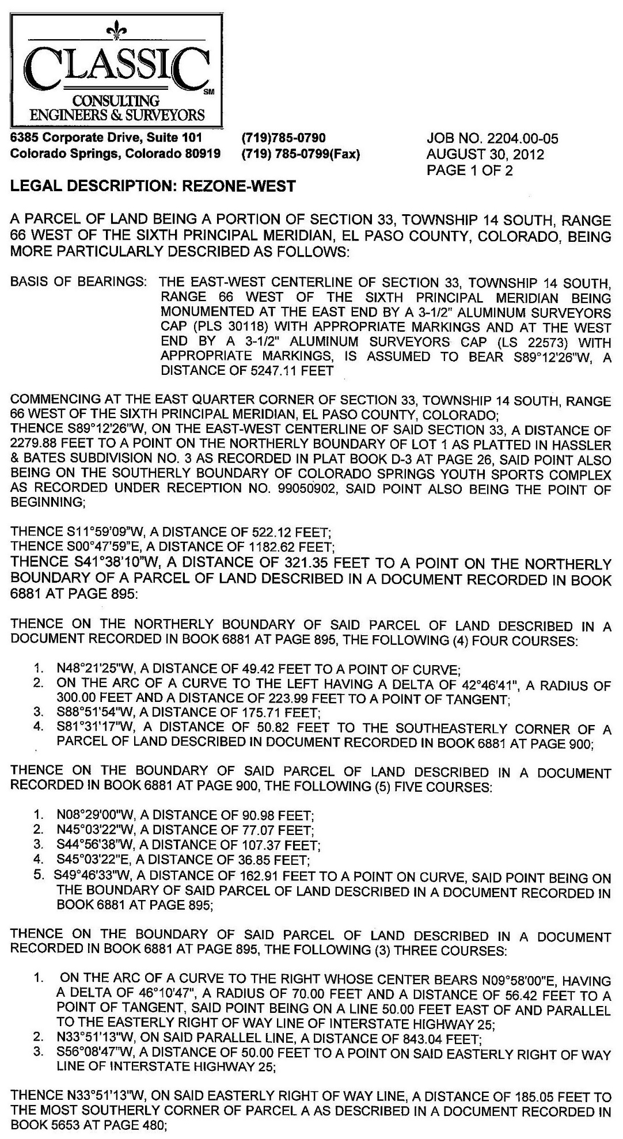
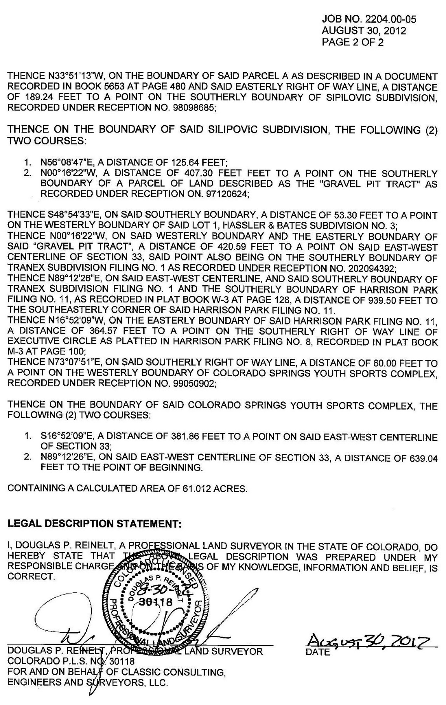

Less and except that certain parcel conveyed by Special Warranty Deed recorded in the records of El Paso County, Colorado on June 10, 2016 at Reception No. 216063129.

EXHIBIT A-2

The Vineyard Parcel

See attached

